Hollywood Japanese Cultural Institute (HJCI)
SMOKED SALMON FUNDRAISER
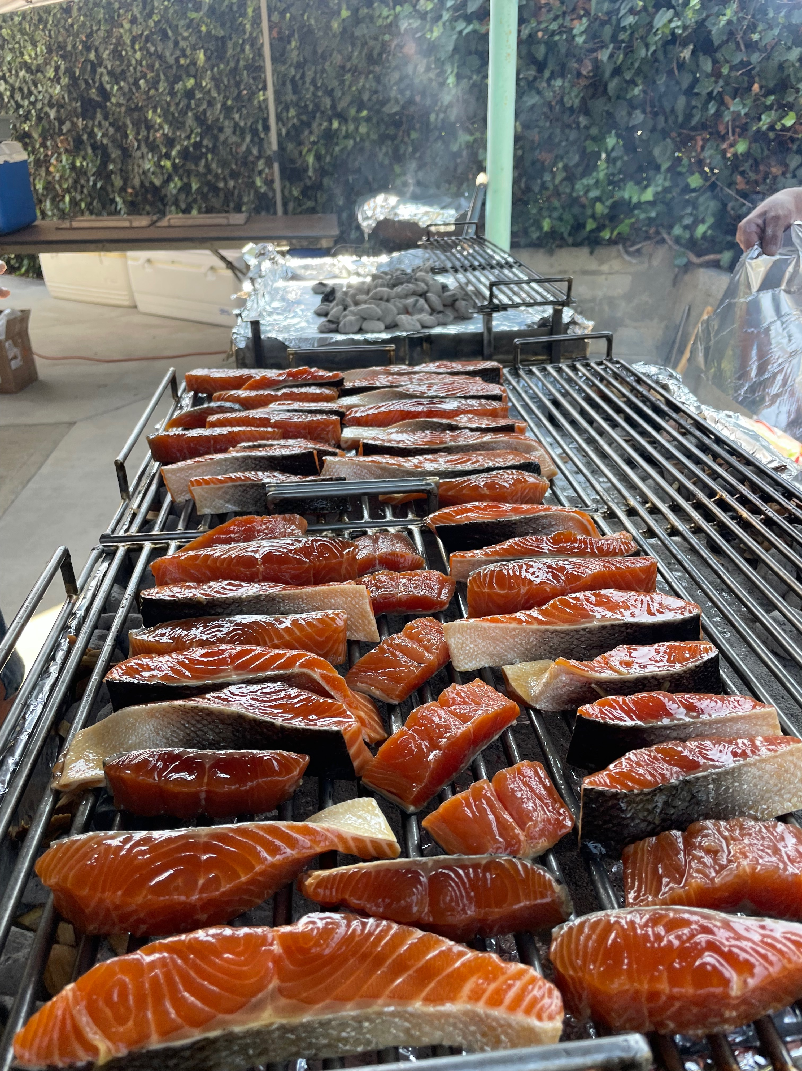
 |  | Date: | Saturday, November 7, 2026
 |  | Time: | 3:00 – 7:00pm (Pick Up Ends: 5pm)
 |  | Place: | HJCI, 3929 Middlebury Street
 |  | Cost: | $30
Name
Phone

Quantity | Total | Please Check if Pick Up Only

We appreciate donations, which are
used towards ongoing building repairs!

Please return this form, and  make checks payable to: | Hollywood Japanese Cultural Institute (HJCI)  3929 Middlebury Street  Los Angeles, CA 90004
Limited Sales – Only the first 200 orders are guaranteed
Order cut off: October 25th

Hollywood Japanese Cultural Institute
3929 Middlebury St. Los Angeles, CA 90004
Phone: (323) 664-2070 www.hollywoodjci.com

September 1, 2026

Dear Members,
We hope you will join us for our fall fundraiser on Saturday, November 7, 2026, at 3pm in the social hall. As you know, our fundraisers provide us with operating revenue, and we sincerely appreciate the donations received from these events.
Back by popular demand, HJCI will be offering smoked salmon dinner. Lightly flavored and expertly prepared, along with rice, vegetable, radish tsukemono, and salad. Dessert will also be provided.
We hope you will join us in the social hall to enjoy this special meal. But, if you’re busy, we are happy to pack your meal to go. But be sure to stop and say hi to the volunteers who work tirelessly to maintain the HJCI for our community groups.
Thank you again for your support and hope to see you in November!

Sincerely,
Casey Hiro Ogino
Casey Hiro Ogino, President

